Upper Deverills Parish Council

9 Beech Grove, Warminster, Wiltshire, BA12 0AB Tel: 01985 213436
Chairman: Miss Louise Stratton Clerk Mrs Sarah Jeffries MILCM

All Parish Council Meetings are open to the Public and Press

Wednesday 9th May 2012

To All Members of the Upper Deverills Parish Council
Dear Councillor,

You are summoned to a meeting of the Upper Deverills Parish Council, at Kingston Deverill Village Hall on Wednesday 9th May 2012 at 6.30pm. The meeting will consider the items set out below.
Before the meeting there will be a public session to enable the people of the Upper Deverills to ask questions of, and make comments, regarding the Parish Council. Questions not answered at this meeting will be answered in writing to the person asking the question, or may appear as an agenda item for the next meeting. Members of the public are asked to restrict their comments, and/or questions to three minutes.
Sarah Jeffries MILCM 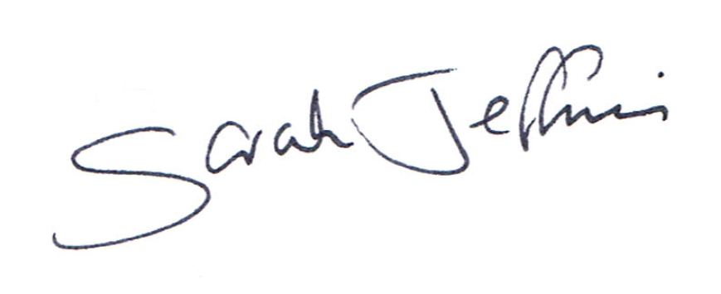
Parish Clerk
----------------------------------------------------------------------------------------------------------------
6.30pm Public Question Time
This section (at the Chairman’s discretion may last up to 15 minutes) is not part of the formal meeting of the Council and minutes will not be produced.

Report from Unitary Councillor

Report from Rural Police Department

Agenda

1. Election of Chairman LGA 1972, Sch 12 para 41(1)

2. Election of Vice Chairman

3. Acceptance of apologies for absence
Schedule 12 of the Local Government Act 1972 requires a record to be kept of the members present and that this record form part of the minutes of the meeting. Members who cannot attend a meeting should tender apologies to the Parish Clerk as it is usual for the grounds upon which apologies are tendered also to be recorded. Under Section 85(1) of the Local Government Act1972, members present must decide whether the reason(s) for a member's absence are accepted.

4. Chairman’s announcements

5. To receive declarations of interests Local Authorities
To receive any disclosure(s) of interest by a Councillor or as an Officer in matters to be considered at this meeting, in accordance with the Local Authorities Code of Conduct order 2007 SI no.1159. (NB this does not preclude any later declarations).
A member must, within 28 days of becoming aware of any changes to the Interests specified in the register of members Interests, provide written notification to the Monitoring Officer.
A member must within 28 days of receiving any gift or hospitality over the value of £25.00, whilst in their official capacity under the code, provides written notification to the monitoring officer of the existence and nature of that gift or hospitality.

6. Exclusion of the Press and Public Standing Order #1c

7. To receive and sign the minutes of the Full Council meeting held on 14th March 2012 (Previously circulated) LGA 1972 Sch 12 para 41(1)

8. Appointment of Committee Members
Council is asked to discuss the appointment of any new committees, confirmation of the terms of reference, the number of members (including, if appropriate, substitute councillors) and receipt of nominations to them.

9. Review of Delegation arrangements to Committees and Sub Committees
Council is asked to discuss the arrangements to committees and sub committees if it has resolved to set them up. LG & housing Act 1989 s 13 Parish & Community Councils (Committees regulations) 1990 SI 1990/2476 LGA 1972 s 101

10. Review and adoption of appropriate standing orders and financial regulations. Council is asked to review the standing orders and financial regulations and inform the Clerk of any changes it wishes to make. The Clerk would recommend adding the following paragraph: If Council is inquorate then matters outstanding will be deferred to the Clerk in conjunction with those members present.

11. Review and adoption of Parish Documentation
Council is asked to review and resolve the adoption of the following Policies, Complaints procedure, Grant Policy, Email Policy, Asset Register and Risk Assessment. The Clerk recommends that Council looks at putting a press policy in place, it has been highlighted to her following her Agenda and Minutes course as best practice. Council have reviewed the following documentation already, Freedom of Information, Dates for the year ahead meetings and has renewed its Data Protection Licence requirements.

12. Drought Consultation
Council is asked to discuss the reply the Clerk has received to the Councils communications.

13. Arrangements for the Public Meeting with Wessex Water
Council is asked to inform the Clerk of any arrangements it wishes her to put into action.

14. Parish Steward
Council is asked to discuss and compile a list of works required, ready for the next Parish Stewards visit. The Highways Engineer has reported to the Parish Steward that he doesn't want any cleansing to be actioned on Dark Lane.
15. Traffic Action Group
Councillor Blue will update Council on the group’s activities

16. Broad Band Action Group
Councillor Greenwood will update Council on the group’s activities

17. Parish Plan
The Clerk will update Council as to where she is with the project.

18. Planning
At the time of actioning this Agenda there were no planning applications to report to Council.

19. Traffic Regulation Orders
Council is asked to discuss the suggested changes to the B3095 speed limit highlighted by Wiltshire Council and inform the Clerk of its comments for the consultation.

20. Early Day Motion
Council is asked to inform the Clerk if it wishes to support this motion.
The Bill would give Town and Parish Councils the right of appeal against the granting of planning permissions to which they had objected and that this policy is backed by the National Association of Local Councils which represents 10,000 Town and Parish Councils in England and by One Voice Wales / Un Llais Cymru which represents Welsh Town and Community Council.

21. Rural Facilities Survey 2012
Council is asked to complete the Survey sent to Council by Wiltshire Council. To be complied at the meeting.

22. Insurance Review Council is asked to approve the renewal of the Insurance Policy

23. Approval and signing off Parish Accounts 2011/2012
Following the Internal Audit Accounts & Audit Regulations 2003 reg 27

24. External Audit
Council is asked to approve the submission of the Internal Audit and any associated documentation.

25. Payments
To review and approve the items of expenditure listed below: LGA 1972 s150(5)
Invoice Wages £ 383.60
Travelling £ 10.80
Shared Travelling costs 4 Courses £ 34.99
Postage £ 5.06
Heat & Light Quarterly charge Dec-March 2012 £ 24.38
Maiden Bradley Computer Contribution £ 15.00
Stationary Plus Parish Plan stationary £ 34.60
Stationary Plus Parish Plan stationary £ 4.99
Community First membership £ 36.00
WALC/NALC Membership £ 114.01
Tung Oil £ 7.73
Receipts
Precept £5850.00

26. Approval of the Banking Arrangements
Council is asked to discuss the Banking Arrangements and approve the Banking Arrangements

27. Clerk’s Report Clerks Risk Assessment report, burial grounds & Churchyards identification.

28. Training

General Power of Competence Council is asked to approve the shared cost of £ 40.00 for the training course and £20.00 for the Clerk’s examination fee for the General Power of Competence. This will mean a cost of £15.00 per Council. LGA 1972 s11

Councillor Training Dates There is a new Councillor Course or the shorter Councillors course available for 2012: See attached documentation. Councillors are asked to indicate if they are able to attend, these courses will help give guidance on what a Parish Council can do for its parishioners and the guidelines Councillors have to follow in their position.

29. Meetings for Councillors to consider attending
Warminster Area Board on Thursday 10 May 2012 at the Chitterne Village Hall situated in the centre of the village, next to the Church and village green. The meeting will start at 7.00 pm with an opportunity to network with Officers and other Parish & Town Councillors with light refreshments available from 6.30 pm.
The following items are on the agenda: Community Budgets, Tackling Financial Exclusion and Area Board Funding

30. Parish Clerks Delegated Powers the Clerk will give Council details of any matters dealt with under her delegated powers since the last meeting of Council. LGA 1972 s101

31. Notice of items to be taken into consideration at the next meeting.
Councillors are asked to highlight items.

32. Items for Parish Newsletter & Notice Boards
Councillors are asked to inform the Clerk.

Grant Applications
The Clerk recommends that the Council discusses placing an advert in the Parish News asking if local groups and clubs would like to apply for grants for 2012-2013.

33. Date of the next meeting there will be a public meeting on the 16th May 2012 at 6.30pm. The Council is asked to note that Wednesday 11th July 2012 is the date of the next Full Council meeting. Council are asked to note that in the exercise of their functions they must take note of the following: Equal opportunities (race, gender, sexual orientation, marital status and any disability); Crime and Disorder, Health and Safety and Human Rights. Any person who may find difficulty in access to the meeting through disability is asked to advise the Clerk (07540 611906) or 01985 213436 email (upperdeverillspc@o2.co.uk) at least 24 hours before the meeting so that every effort may be made to provide access.

